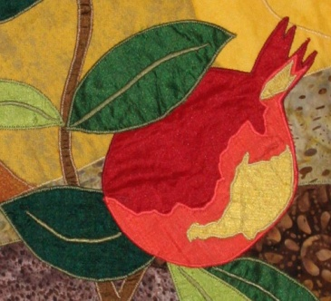

**Princeton Reconstructionist Synagogue:   
a String of Pearls**

P.O. Box 3332, Princeton, NJ 08543

**Membership Form: 2022-’23**

*Welcome!*

Name(s)___________________________________________________________________

Address ________________________________________

________________________________________

Phone(s)_________________________ _____________________________

E-mail(s)________________________________ __________________________________________

Please Complete the form and return it with your payment to **String of Pearls** at the above address.

*Talents and Connections in Your Household*

Do you have any talents or hobbies that you could share with the congregation, *e.g.* musical, culinary, artistic, or __________________________________________________________?

Do you have any professional skills that you could share with the congregation, *e.g.* legal, educational or financial? _______________________________________________________

*Areas of Interest in Jewish Learning*

Please circle or initial any of the following areas of interest; feel free to add your own.

Talmud Torah Hebrew chanting Torah/ Haftarah singing the liturgy

Jewish Cookery Social Action G'mlut Chasidim Women's Book Group

**- - - - - - - - - - - - - - - - - - - - - - - - - - - - - - - - - - - - - - - - - - - - - - - - - - - - - - - - - - - - - - - - - - - - -**

**Payment of Dues and Donations**

Enclosed is my check for $__________ toward: ___ Family dues ($1,000) ___ Single dues ($500)

*PAYMENT OPTIONS*: I will make four equal payments of $__________ by:

September 23rd, December 1st, February 1st and May 1st, ***or***pay according to the following schedule:

______________________________________________________________________________

____I am unable to pay dues in full at this time and agree to both:

1. Contact **Joan Sanchez**, Princeton Reconstructionist Synagogue Treasurer at 786 273-6926 **on or before September 23, 2021 to discuss my payment plan and options** *and* to

2. **Communicate regularly with her**. I understand that all information is confidential and that *no one is ever turned away for financial reasons.*

Signed: _________________________________________________ Date: _____________________